Felting Workshop
with
Catherine Dunham

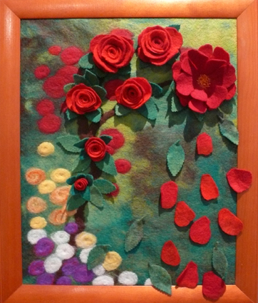

Make an individual piece of flat felt depicting a landscape or still life, using merino wool and other fibres. You will learn how to plan, design, layout and make a felt picture you can hang on the wall or use to make a cushion cover.

Saturday 14th June in the Moore Workshop Space
Blue Knob Hall, Blue Knob Road
9.30am – 4.00pm
Bring your own lunch or order a delicious meal from the BKH café

Cost $60 per person includes materials
Spaces limited
Bookings essential
Phone 02 66897101 or 02 66 841262
for more information and to make bookings

Profile
Catherine has been felting for many years both as an artist and a teacher. Originally self taught and inspired by a workshop with Polly Sterling at Wild Turkey Studio in the early nineties, she has run felting classes, made large interactive pieces for public display and has taught felting to hundreds of children and adults.

